# WiFi Jamming Attack and Mitigation

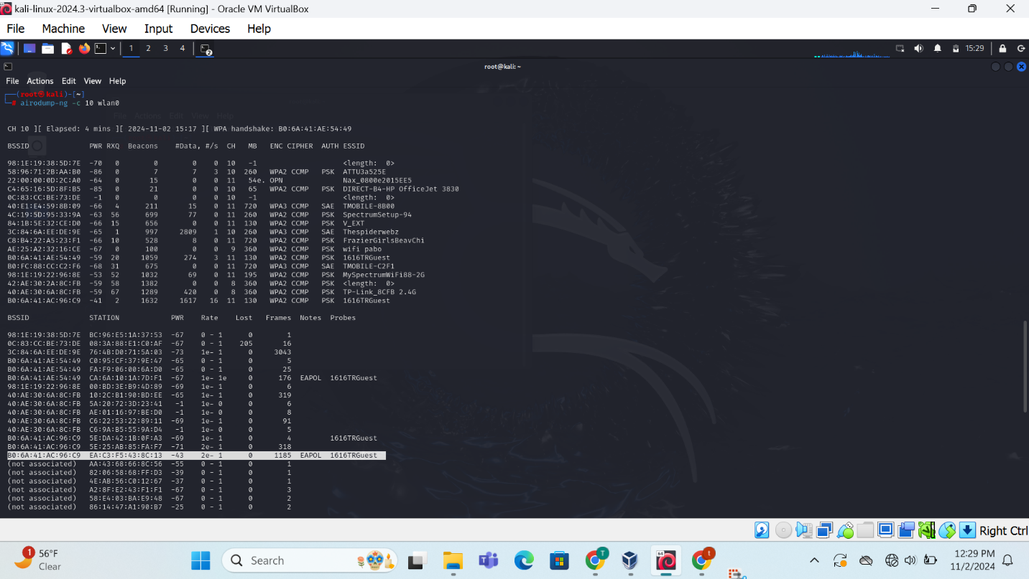

Each line in the output represents a detected wireless network, with the following information:

* **BSSID:** The unique identifier of the network's access point.
* **RSSI:** The Received Signal Strength Indicator, a measure of the signal strength.
* **#Data:** The number of data packets received from the network.
* **ENC:** The encryption type used by the network (e.g., WPA2, WPA3).
* **CIPHER:** The cipher suite used for encryption.
* **AUTH:** The authentication method used (e.g., PSK, SAE).
* **ESSID:** The network name (SSID).

**Potential Security Implications:**

several potential security implications can be identified:

1. **Weak Encryption:** Networks using older encryption standards like WEP or WPA are more vulnerable to attacks. It's important to use WPA2 or WPA3 with strong passwords.
2. **Default SSIDs and Passwords:** Networks with default SSIDs and passwords are easy targets for attackers. It's crucial to change the default settings and use strong, unique passwords.
3. **Rogue Access Points:** Rogue access points are unauthorized access points that can be used to intercept traffic or provide unauthorized access to a network. Kismet can help detect rogue access points.
4. **WPS Vulnerabilities:** Wi-Fi Protected Setup (WPS) is a feature that allows easy network setup but is vulnerable to brute-force attacks. It's recommended to disable WPS if possible.

* **Strong Passwords:** Use strong, unique passwords for your wireless network. Avoid using easily guessable passwords.
* **WPA3 Encryption:** Use WPA3 encryption, which is more secure than WPA2.
* **Firewall Configuration:** Configure your firewall to block unauthorized access to your network.
* **Regular Updates:** Keep your router's firmware and software up to date to address security vulnerabilities.
* **Network Monitoring:** Use tools like Kismet to monitor your network for suspicious activity.
* **Disable WPS:** If possible, disable WPS on your router to mitigate potential vulnerabilities.